NAME: ALISHBA ZAINAB
ROLL NO: 23-BSE-006
SUBMITTED TO : SIR SHOAB
LAB 3

Task 1
Handling Local and Remote Commit Conflicts (Pull vs Pull --rebase)
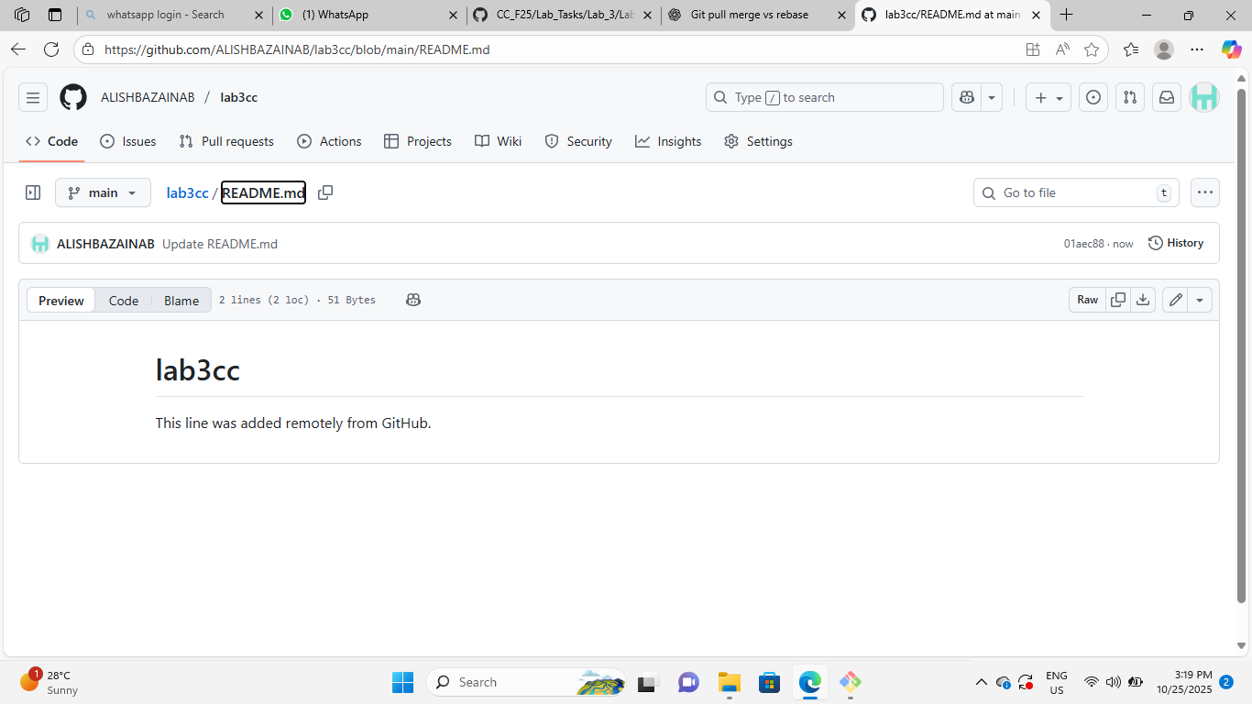

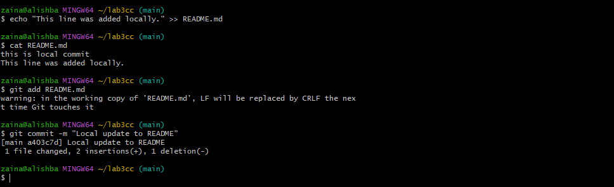
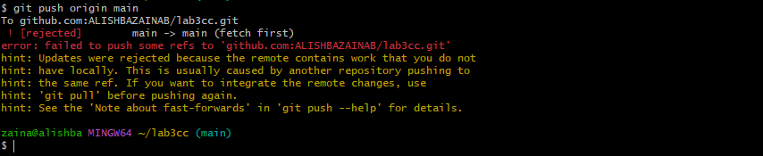
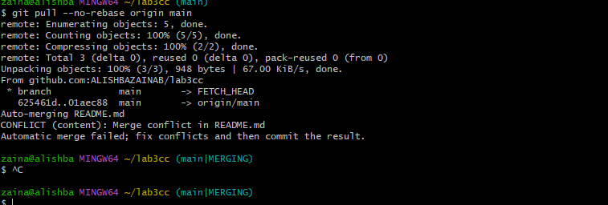

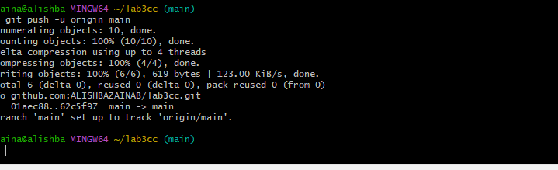
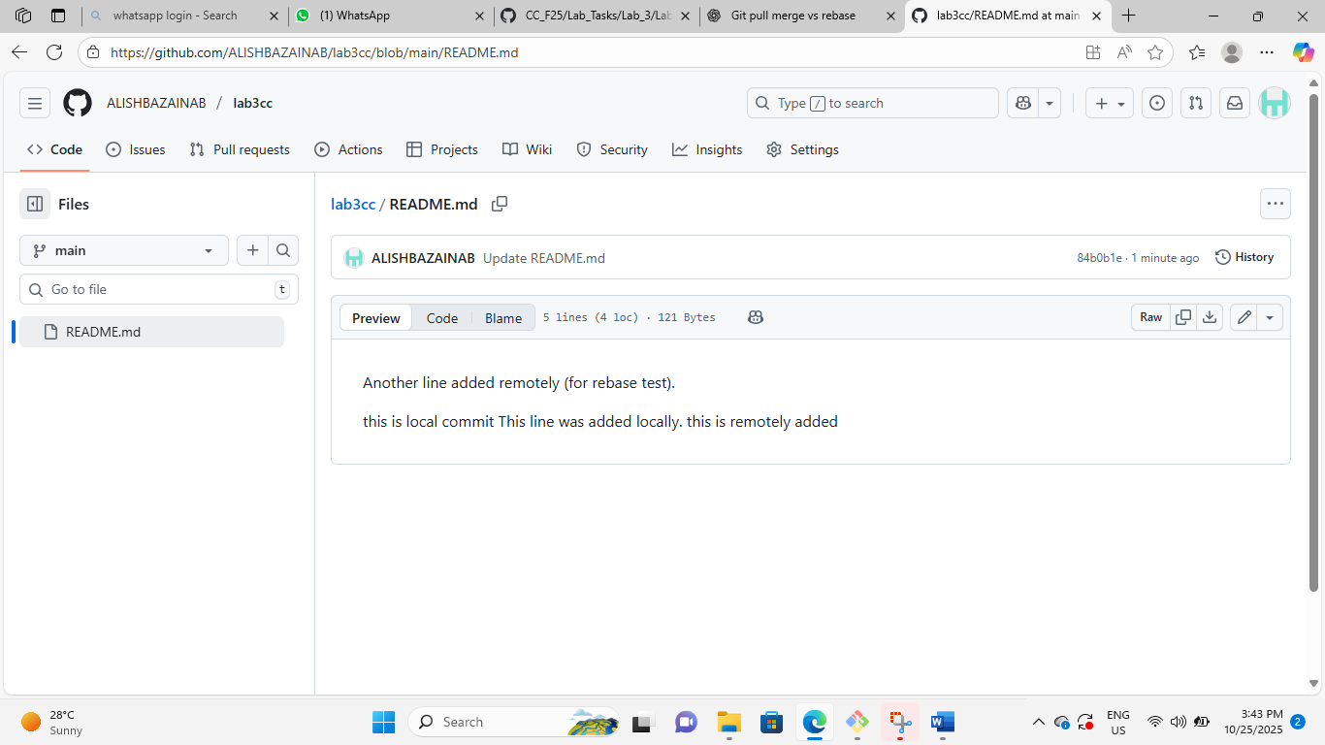
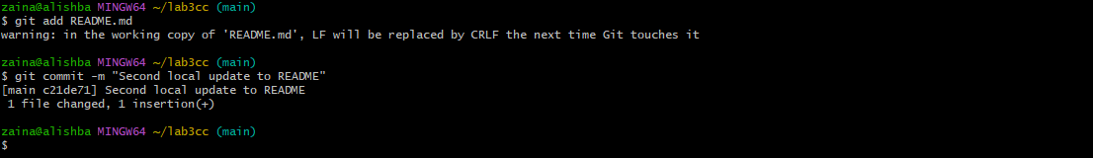

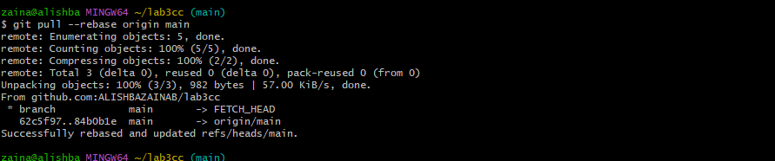
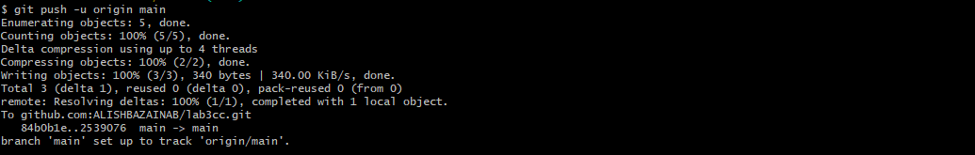
Task 2
Creating and Resolving Merge Conflicts Manually

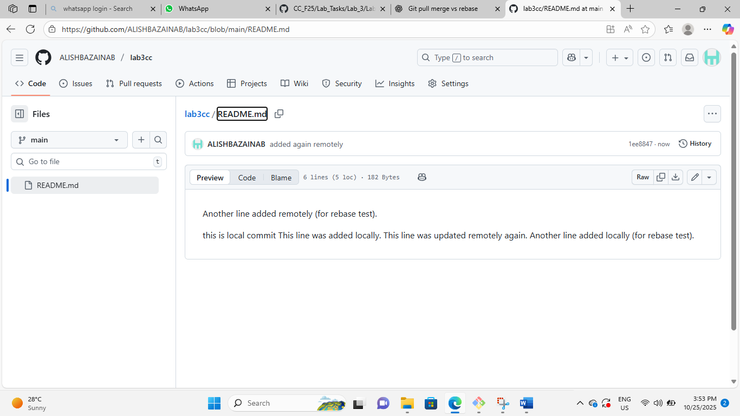

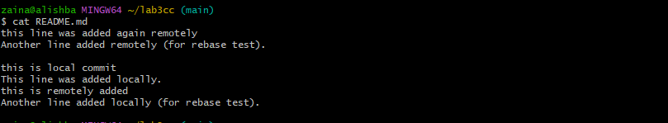
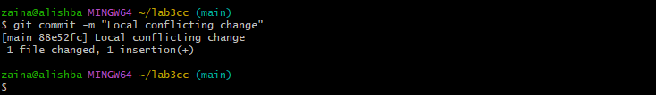
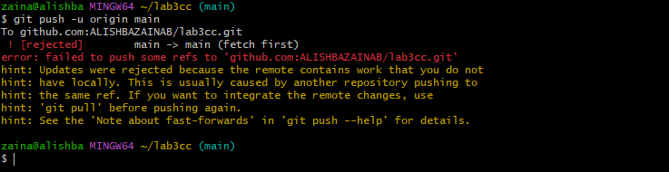
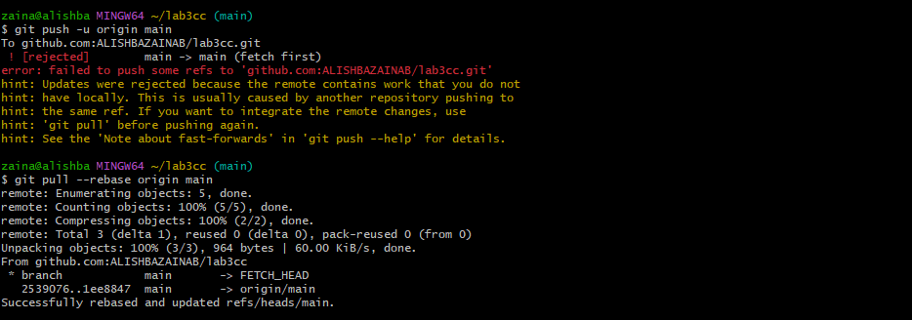

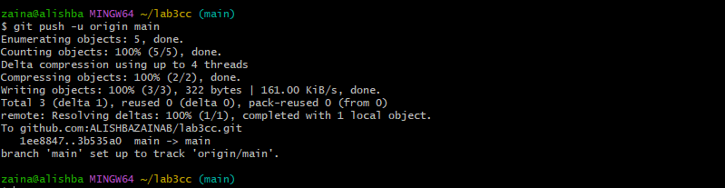
Task 3
Managing Ignored Files with .gitignore and Removing Tracked Files
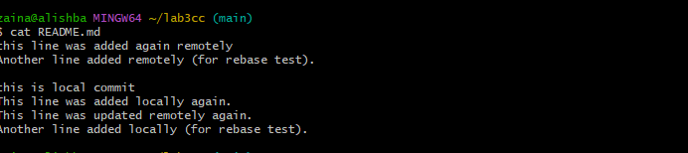

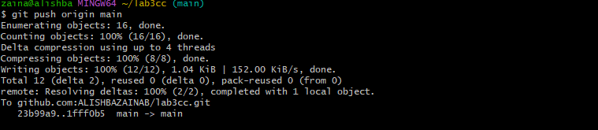
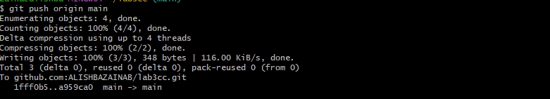

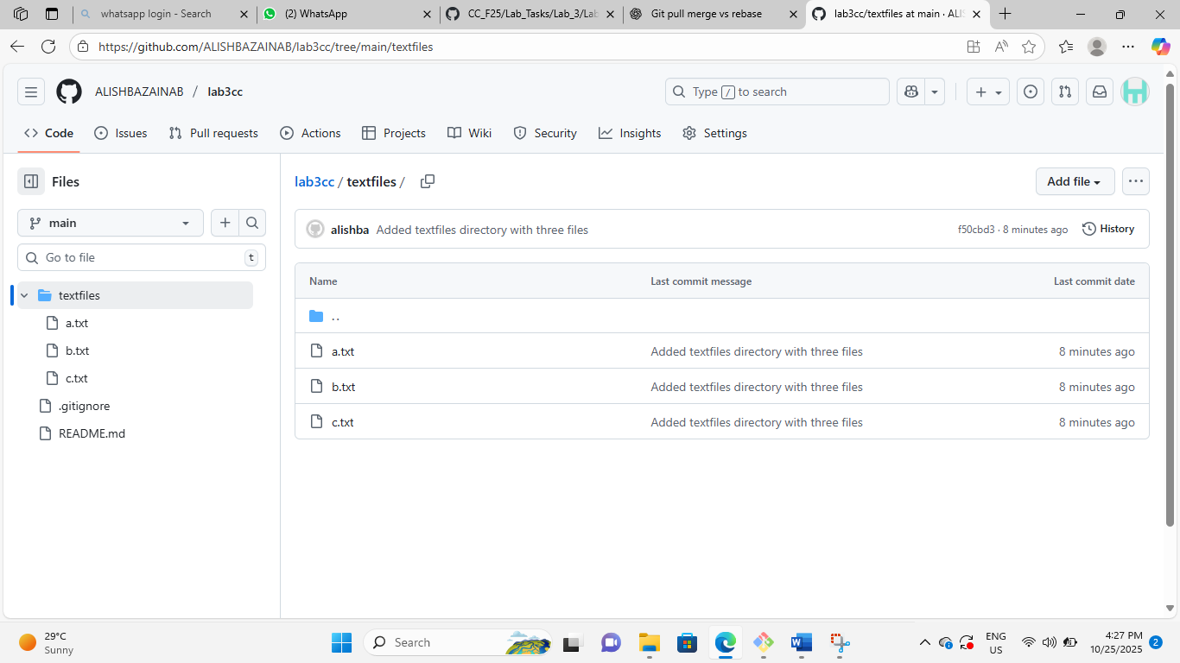
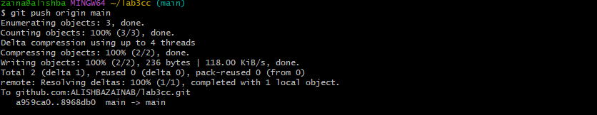

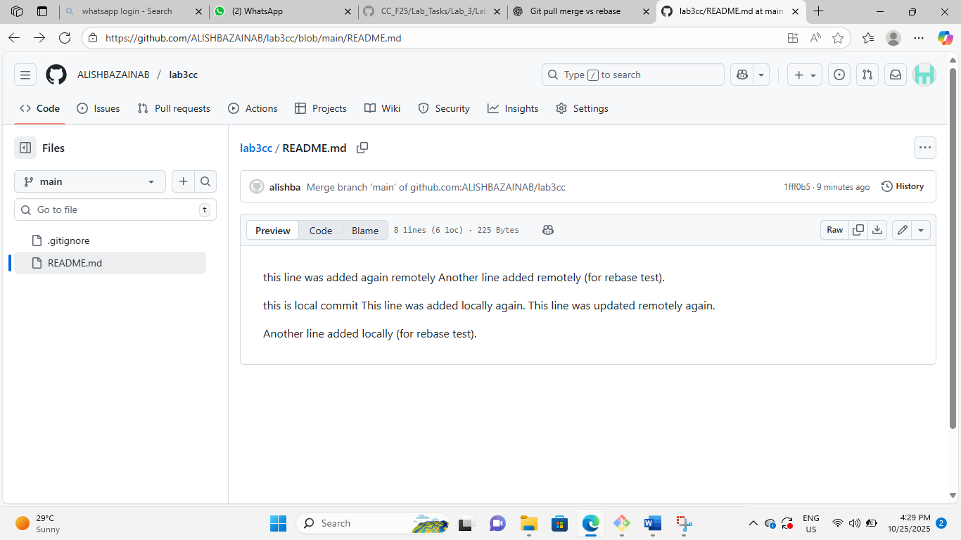

Task 4
Create Temporary Changes and Use git stash

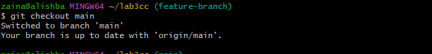
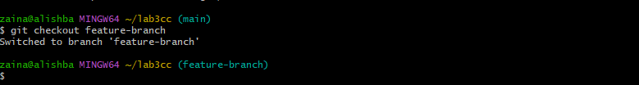
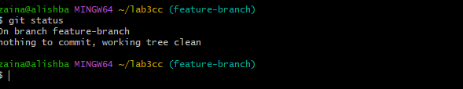
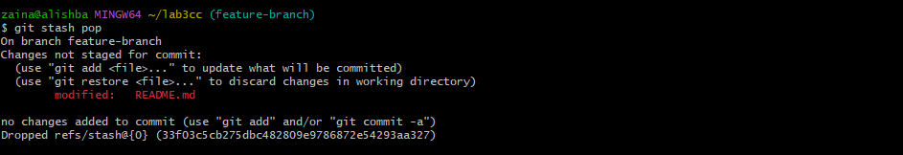
Task 5
Checkout a Specific Commit Using git log
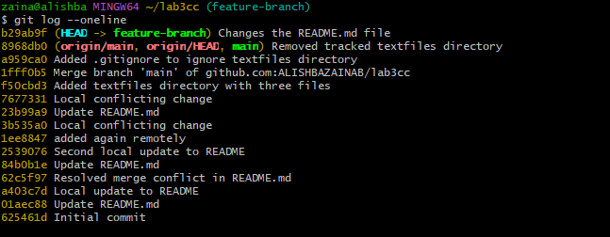
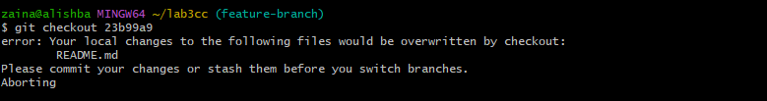
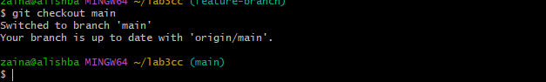
Task 6
Resetting Commits (Soft vs Hard Reset) (With Verification Steps)
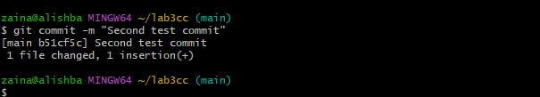
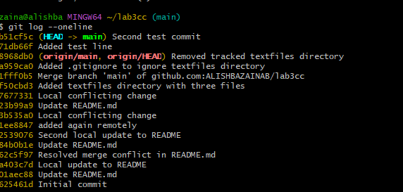
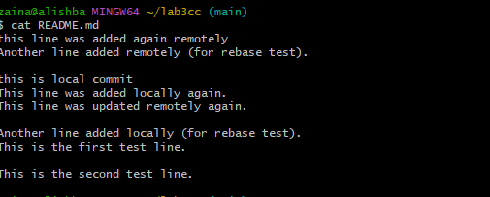

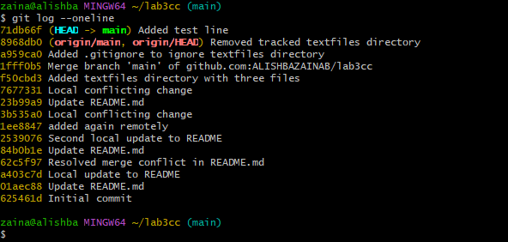
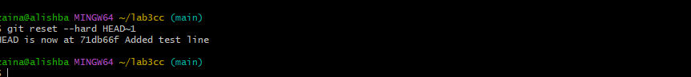
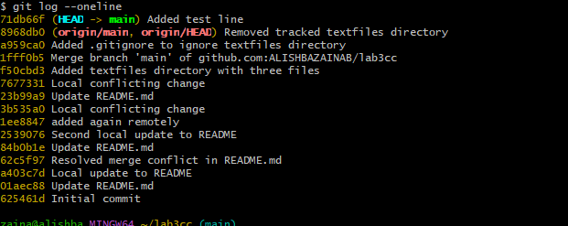

Task 7
Amending the Last Commit
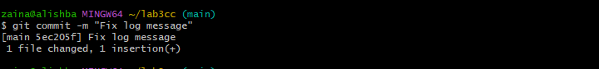
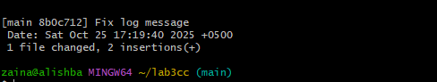

Task 8
Reverting a Commit (Safe Undo on Remote Branch)
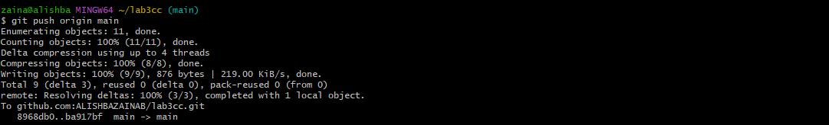
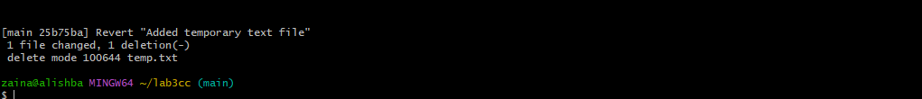
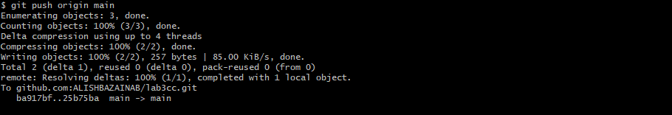

Task 9
Force Push (With Caution)

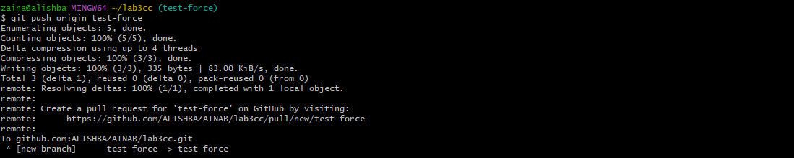

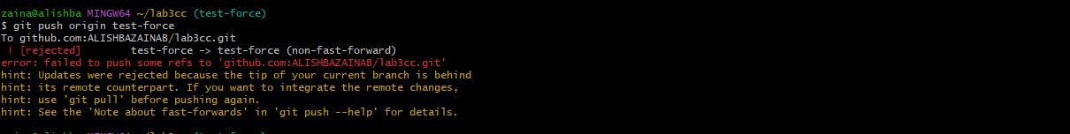

Task 10
Running Gitea in GitHub Codespaces via Docker Compose
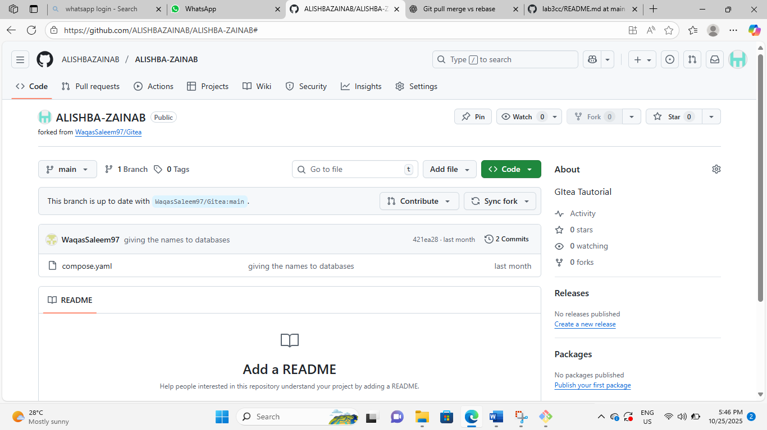
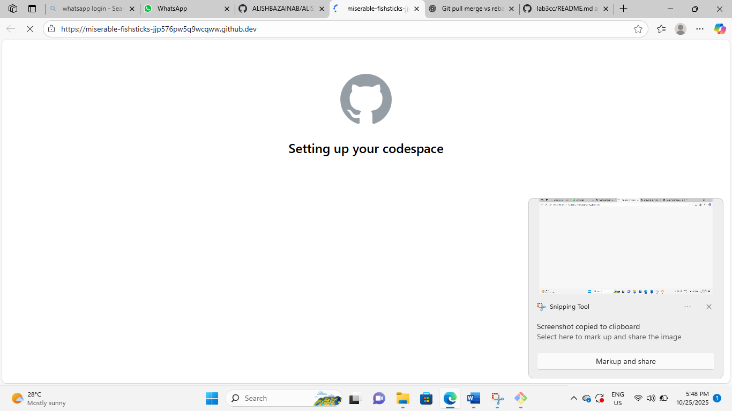

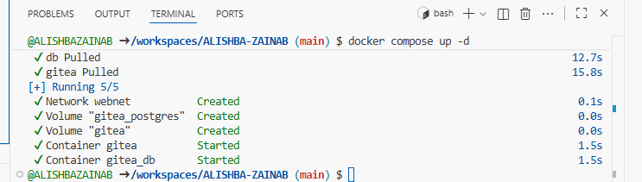

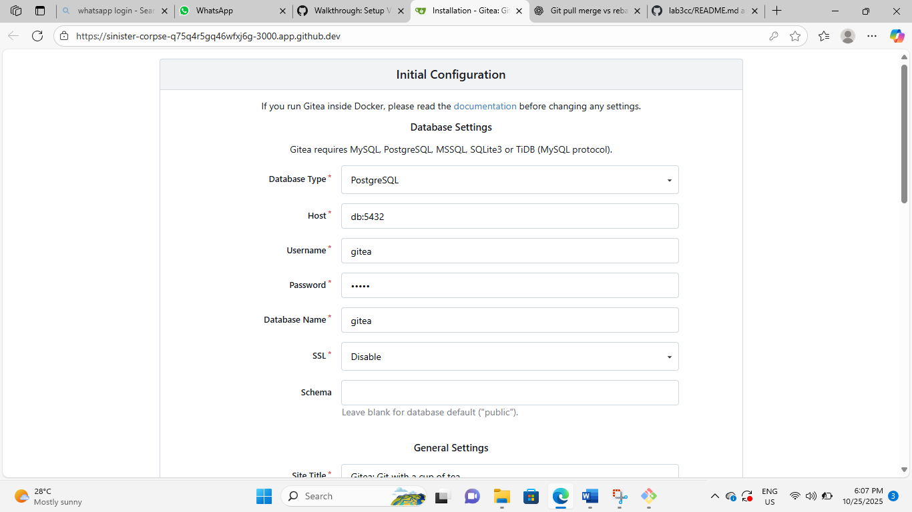

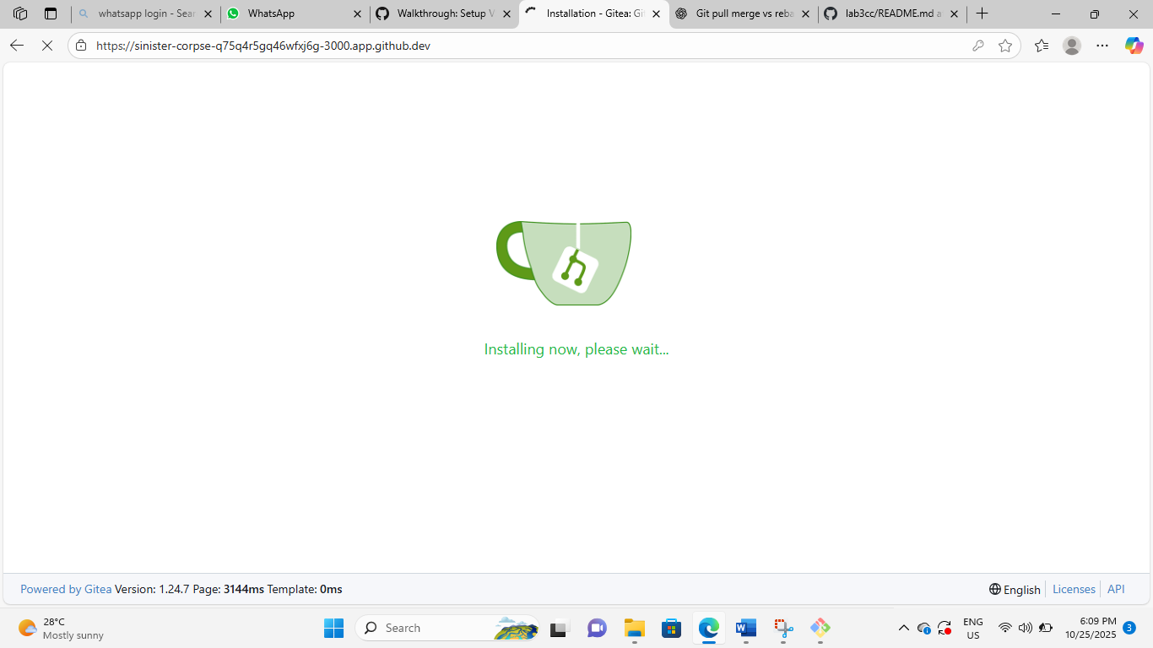
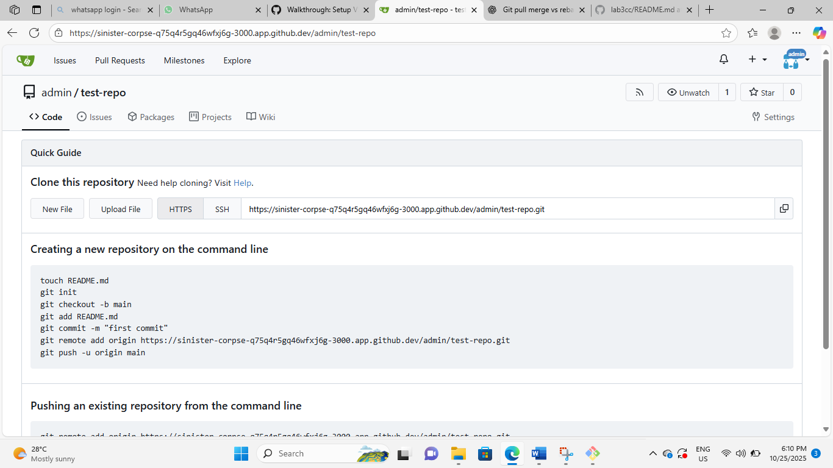

Task 11
Creating a GitHub Pages Portfolio Site
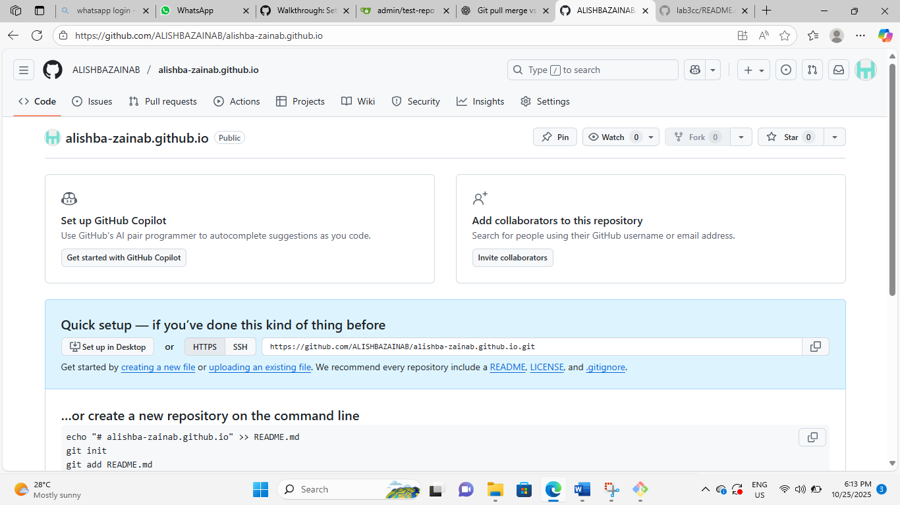

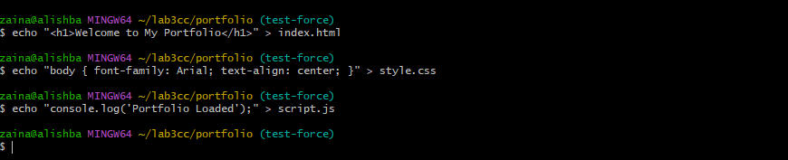
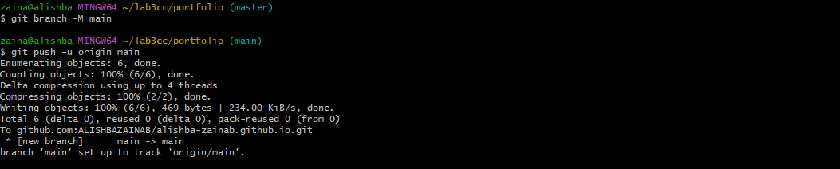
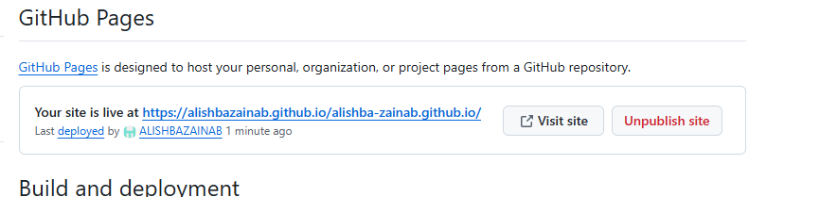
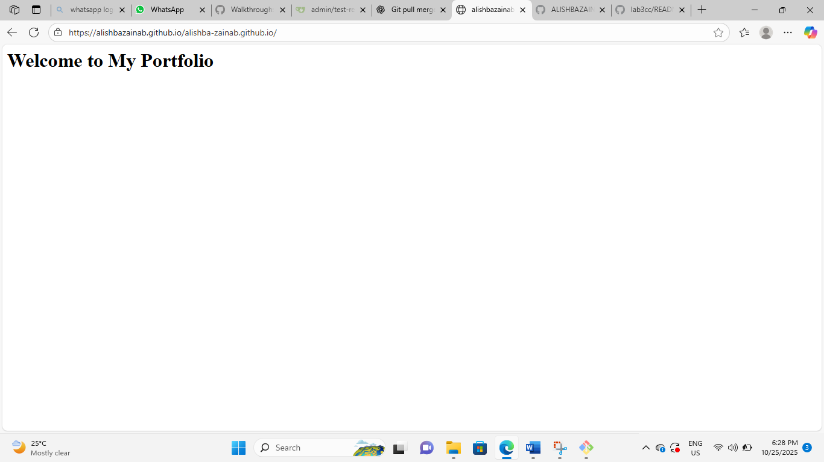

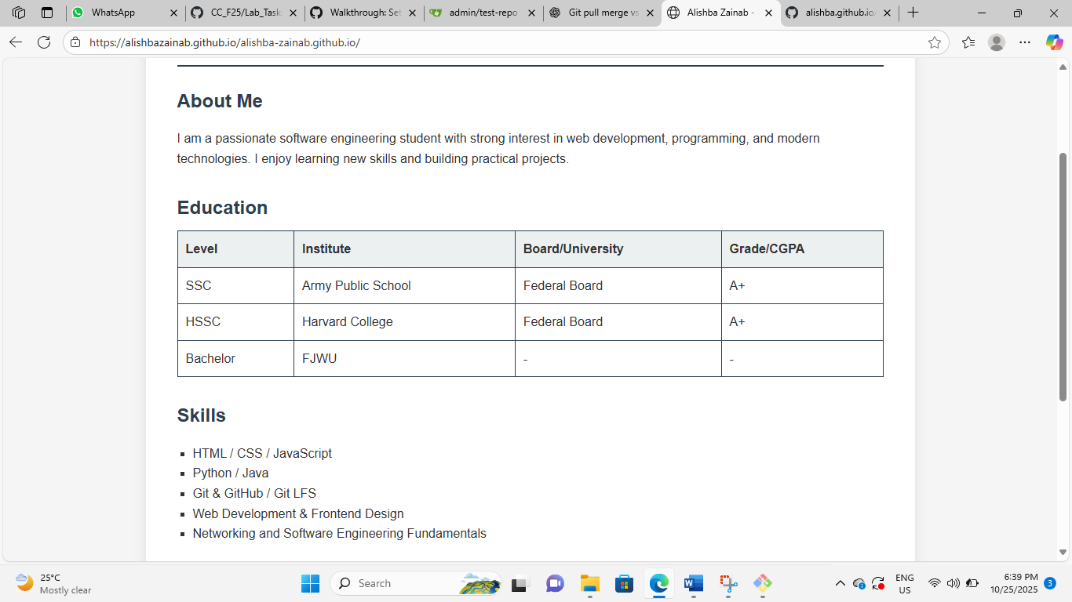

Evaluation questions
Question 1
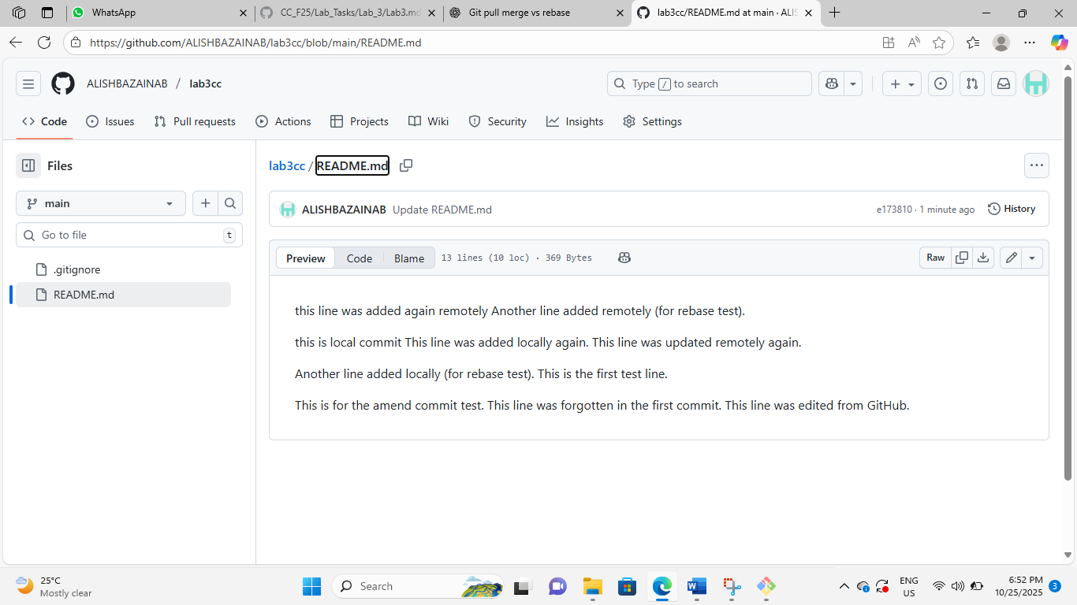

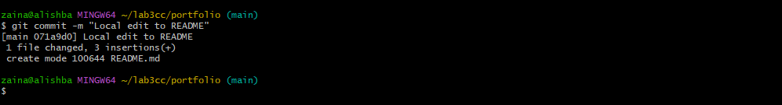







Question 2




Question 3





Question 4





